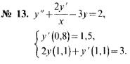

[0,8; 1,1]

//y’ (0,8) = 1,5 => y (0,8) = 1,5x = 1,5 x 0,8 = 1,2 = y0 ,

y’’ = (y­­i + 1 – 2yi + yi - 1)/h2 , y’ = (y­­i + 1 – yi - 1)/2h ,

(y­­i + 1 – 2yi + yi - 1)/h2 + 2 (y­­i + 1 – yi - 1)/2hx­i – 3yi = 2 ,

y' (0,8) = (-y2 + 4y1 – 3y0)/2h = 1,5 ,

2yn + (3yn – 4yn - 1 + yn - 2)/2h = 3 ,

=>

y­­i + 1 – 2yi + yi - 1 + h (y­­i + 1 – yi - 1)/x­i – 3yi h2 = 2h2 ,

-y2 + 4y1 – 3y0 = 3h ,

4hyn + 3yn – 4yn - 1 + yn - 2 = 6h ,

=>

-3y0 + 4y1 – y2 = 3h , i = 0 ,

(1 – h/xi) yi - 1 – (2 + 3h2) yi + (1 + h/xi) yi + 1 = 2h2 , i = 1 .. (n - 1) ,

y­n – 2 – 4yn - 1 + (4h + 3) yn = 6h , i = n ,

=> f­1 (x, h) = (1 – h/x), f­2 (h) = (2 + 3h2), f­3 (x, h) = (1 + h/x), f4 (h) = 2h2 =>

-3y0 + 4y1 – y2 = 3h , i = 0 ,

f1 (xi, h) yi - 1 – f2 (h) yi + f3 (xi, h) yi + 1 = f­4 (h) , i = 1 .. (n - 2) ,

y­i – 2 – 4yi - 1 + (4h + 3) yi = 6h , i = n - 1 ,.

h = 0,1 => n = 4 ,

-3y0 + 4y1 – y2 = 3h ,

f1 (x1, h) y0 - f2 (h) y1 + f3 (x1, h) y2 = f­4 (h) ,

f1 (x2, h) y1 – f2 (h) y2 + f3 (x2, h) y3 = f­4 (h) ,

y1 – 4y2 + (4h + 3) y3 = 6h ,

=>

-3y0 + 4y1 – y2 = 0,3 ,

0,88y0 – 2,03y1 + 1,11y2 = 0,02 ,

0,9y1 – 2,03y2 + 1,1y3 = 0,02 ,

y1 – 4y2 + 3,4y3 = 0,6 ,

|  |  |  |  |  |  |
| --- | --- | --- | --- | --- | --- |
| -3 | 4 | -1 | 0 |  | 0,3 |
| 0,88 | -2,03 | 1,11 | 0 |  | 0,02 |
| 0 | 0,9 | -2,03 | 1,1 |  | 0,02 |
| 0 | 1 | -4 | 3,4 |  | 0,6 |

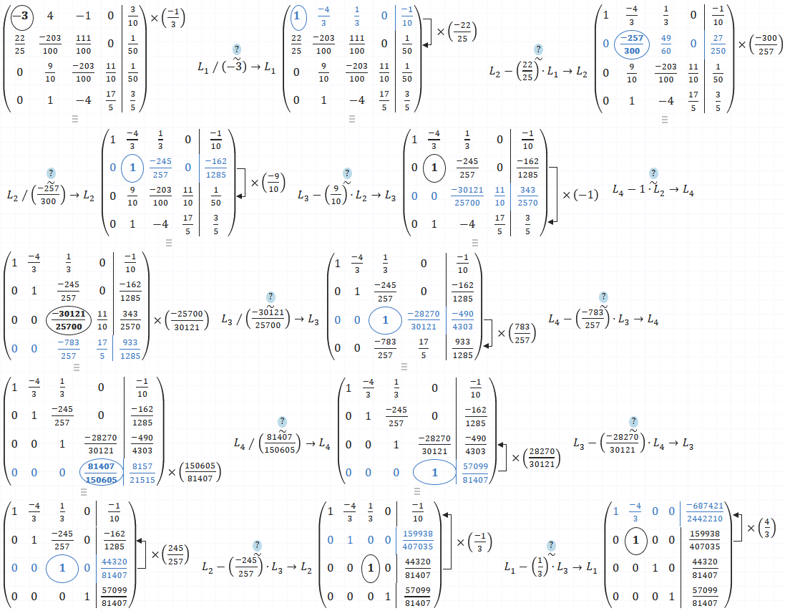

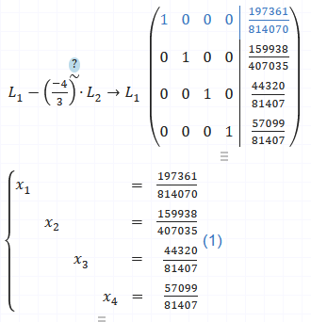

x0 = 0,8 , y­0 = 197361/814070 = 0,24243738253467146559878143157222 ,

x1 = 0,9 , y1 = 159938/407035 = 0,39293426855184443598216369599666 ,

x2 = 1 , y2 = 44320/81407 = 0,54442492660336334713231048926996 ,

x3 = 1,1 , y­3 = 57099/81407 = 0,70140159937106145663149360620094 ,

n = 8 ,

=>

-3y0 + 4y1 – y2 = 3h , i = 0 ,

f1 (xi, h) yi - 1 – f2 (h) yi + f3 (xi, h) yi + 1 = f­4 (h) , i = 1 .. (n - 2) ,

y­i – 2 – 4yi - 1 + (4h + 3) yi = 6h , i = n - 1 ,.

-3y0 + 4y1 – y2 = 3h , i = 0 ,

f1 (x1, h) y0 – f2 (h) y1 + f3 (x1, h) y2 = f­4 (h) , i = 1 ,

f1 (x2, h) y1 – f2 (h) y2 + f3 (x2, h) y3 = f­4 (h) , i = 2 ,

f1 (x3, h) y2 – f2 (h) y3 + f3 (x3, h) y4 = f­4 (h) , i = 3 ,

f1 (x4, h) y3 – f2 (h) y4 + f3 (x4, h) y5 = f­4 (h) , i = 4 ,

f1 (x5, h) y4 – f2 (h) y5 + f3 (x5, h) y6 = f­4 (h) , i = 5 ,

f1 (x6, h) y5 – f2 (h) y6 + f3 (x6, h) y7 = f­4 (h) , i = 6 ,

y­5 – 4y6 + (4h + 3) y7 = 6h , i = 7 ,.